**SRA 311 Risk Management Project Paper Requirements**

**Formatting Requirements:**

The final paper should be in Times New Roman 12 Font, single-spaced, and equal to or less than 12 pages.

**Content Requirements:**

Please make sure to include the following sections in your proposal

1. **Project Link**
2. **Executive Summary**
   1. Define the organization you are going run your risk analysis on.
   2. Outline its basic information, its major assets (use SHEL model from Chapter 1) and the major security challenges it is facing.
   3. Define the risk management model you use for the analysis (ex. NIST model) and explain how you followed this framework in each step of your analysis
   4. What benefits can your project bring to the organization? What are the possible constraints for your analysis (Ex. deterministic requirements f5rom the stakeholders, legal compliance, and budget issues)
3. **Background Information of the Organization**
   1. Name of the organization and its basic information (Ex. Industry Sector, CEO and important members, number of employees, number of branches, offices, organizational structure, manufacturing facilities—You can visualize in a tree diagram, …)
   2. Define its missions in terms of multiple success criteria and talk briefly about each criterion (Why is it important to the company)
   3. List all the essential business functions currently run by the organization, pick at least 3 of them to focus on (these functions have to be closely related with the missions of the organization and contain rich information for risk analysis). Draw flow charts for these functions and explain how they work in more details.
4. **Stakeholder Analysis**
   1. Create a table for all possible stakeholders of the company
   2. In the table, define definitive, dominant stakeholders, dangerous stakeholders and dependent stakeholders of your project in terms of their urgency, legitimacy and capacity attributes (refer to lecture slides 2 and Chapter 1)
   3. Briefly talk about the impact of your project on the stakeholders’ interests
5. **Project Scope Statements**
   1. Use the important business functions you have selected in **Background Information of the Organization** section
   2. Explain about why you want to focus on these functions in your analysis--how they are relevant to the mission criterions, survivability of the organization.
   3. Create a table for each of the selected business functions to list the assets (data, hardware, software system, employees, machinery, and facilities) which are related to it, the input it will need to work.
   4. Explain the possible security accidents that can happen with each of the selected business functions (use Rasmussen’s accident categories or James Reason’s accident categories from Chapter 1)) and specify which accidents you will cover and which one you won’t cover in the analysis.

1. **Risk Analysis**

In this part, you need to run risk analysis on the selected business functions. You will have the flexibility to organize the report in your own structure based on the risk management framework you follow. However, your analysis needs to meet the requirements listed below:

1. You need to use a combination of both qualitative analysis and quantitative/semi-quantitative analysis. The qualitative analysis will help pre-screen the important accidents for quantitative/semi-quantitative analysis. In qualitative analysis, list at least 3 hazardous events for each of the business functions you have selected. done
2. Use Bow-Tie model to analyze all the hazardous events in your qualitative analysis (Need to include information about hazards, consequence, triggering events, proactive & reactive barriers etc., refer to Chapter 5 in the textbook). done
3. Specify what are the risks influencing factors (RIF) (Refer to Section 2.5 in the textbook) for the hazardous events in your qualitative analysis. done
4. Based on the RIFs, barriers, hazards and consequence spectrum, create your own rating scheme for qualitative risk assessment. Take the highest-ranked hazardous event from each business function (all 3 of them) for quantitative/semi-quantitative risk analysis

Use the risk management blocks from QR 16 (Ryan explained, he will create graph to go off of) Assign risk rating

1. Collect/simulate data to support your quantitative analysis done
2. Create data dossier for your experiment data in the quantitative/semi-quantitative analysis following the format in Section 7.9 in the textbook. done
3. Develop accident scenarios (Section 2.2.3 in the textbook) for the hazardous event in your semi-quantitative analysis. Please conduct causal and frequency analysis (Chapter 10 in the textbook) (cause-effect analysis) on the hazardous events in your quantitative/semi-quantitative risk analysis. Use fault tree analysis to estimate the probabilities of at least two hazardous events out of the three hazardous events in your quantitative/semi-quantitative risk analysis. (Ryan to do a second one)
4. Conduct barrier analysis (Chapter 12 in the textbook) for the hazardous events in your quantitative/semi-quantitative risks analysis. Make sure to create a table for hazard-barrier matrices and draw safety barrier diagrams (I can create the hazard-barrier matricies and the safety barrier diagrams)

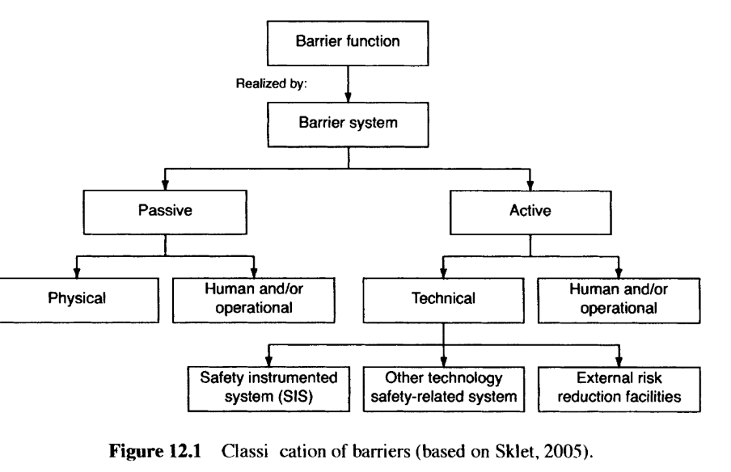

1. Conduct cause-consequence analysis (Chapter 11 in the textbook) to study the development of accident scenarios. Make sure to use event tree analysis (ETA) (Section 11.2 in the textbook) to analyze the consequences (You can calculate the expected level of consequences for the hazardous event using the impact level and probabilities of all the possible consequences from your event tree analysis following the example I give in page 19 of lecture 10 slides) done
2. In your data analysis, at least create one of the accident scenarios based on personnel safety issues and calculate human fatalities measures in your analysis (ex. IRPA, PLL) (Section 4.3 risk to people in the textbook) ryan done
3. Based on your proposed controls, please rerun the event tree analysis and fault tree analysis and recalculate the risk factors using the adjust probabilities and consequences. Make comparison between risk levels before the control and after the control. Justify your control effectiveness with ALARP principle (Chapter 4 in the textbook) done (second piece of the slide)